18. Garlasco – Pavia and Pavia rest day
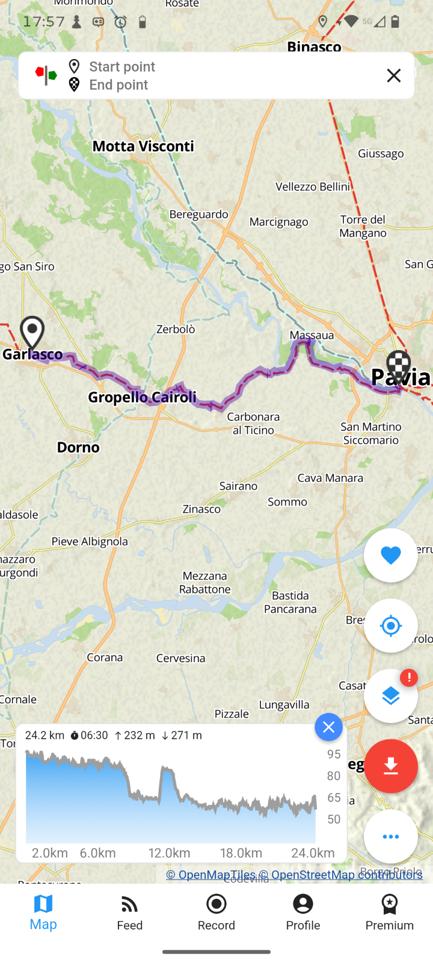
18-19-20 th^{th} June

Accommodation
Ostello Santa Maria in Betlem
Address: Via Pasino 7, 27100, Pavia, Pavia, Italy
Phone Numbers: +39 3313046459
Email: info@ostellosantamariainbetlem.com
Religious structure No. of places available: 21
Overnight stay only. Closed every day between 10am and 12.30pm.

B&B Residenza I Mille
Address: Via dei Mille 117, 27100, Pavia, Pavia, Italy
Phone Numbers: +39 3348637017
Email: info@residenzaimille.it
In the heart of the historic center of Pavia, near the Ponte Coperto, the Bed & Breakfast Residenza I Mille offers its guests a comfortable and welcoming stay, in the tranquility of a family environment.
B&B, No. of places available: 4 Washing machine Via Francigena stamp

32bnb Camerecaffè
Address: Corso Garibaldi 32B, 27100, Pavia, Pavia, Italy
Phone Numbers: +39 3913969913
Email: info@32bnb.it

Lombard guesthouse, No. of places available: 8
How to get there:
We are located on the axis of the Via Francigena near the Church of S.Luca (Pilgrims' Hospital)
Price for overnight stay + complimentary breakfast:
Double room €105
Single room €85
Additional 3rd bed €25
Double loft €125, single use €100
Additional 3rd bed €25

